Ivy Plant Inc.

Overview

“Ivy Plant Inc.” is a fictional name I created to associate with the dataset. A large-scale company that sells three different groups of plants (indoor, outdoor, and landscape) to individuals and businesses worldwide.

The dataset mimics the operations of a real-life plant company with similar operations. I downloaded it from a GitHub repository.

The dataset is an Excel file containing three tables split up into three tabs:
- Plant_FACT: This table contained sales invoices for the plants. It had a product I.D. and account I.D. column that could be connected with the other tables.
- Accounts: Containing all the information about each specific account included in the sale of the plants. An Account ID column was the unique identifier for the table.
- Plant hierarchy: This section had information about the products(plants). The products were assigned based on family, group, name, size, and type.

It contained 2000+ rows of data spanning three years (Jan. 2022 - Apr. 2024).

Research Questions

At first glance, the dataset was relatively clean and needed a few tweaks for analysis. I was able to identify the following as key insights that could be useful in a real-world scenario:
- Total Sales: how much revenue was generated?
- Total Quantity of Goods Sold: how much is being sold?
- Gross Profit: There was a column with the cost of goods sold. This could be useful in determining how sustainable the current prices of goods are.
- Year-To-Date & Prior-Year-To-Date: Apart from the total sales, it would be interesting to find out how well sales numbers compare with previous years within the same period. The data cuts off in the first quarter of 2024, so this insight could be useful to prepare and re-strategize if needed for the rest of the year.
- Regional Performances: Each of the accounts and their locations was listed so I could view numbers from these regions to see how well each area was doing.
- Account Profitability: Besides the regional performances, I could also view the accounts performing well in gross profit and those needing intervention.
- Sales based on product type; what type of plants do customers buy more regularly?

Data Cleaning

As earlier mentioned, the dataset was relatively clean and only needed minor adjustments. To aid reproducibility, I performed these cleaning operations using Power Query.

I loaded the dataset into Power Query and performed the following operations:
- Modified the Column names; a few were misspelled and inconsistent
- Renamed the tables to reflect their contents appropriately
- The Sales table was to be my Fact Table. Therefore, I identified the column on the other tables to be joined with the Fact Table and removed all duplicates.
- I noticed null values on the Accounts ID column within the Accounts table and removed them as they were inconsequential and likely to throw errors.

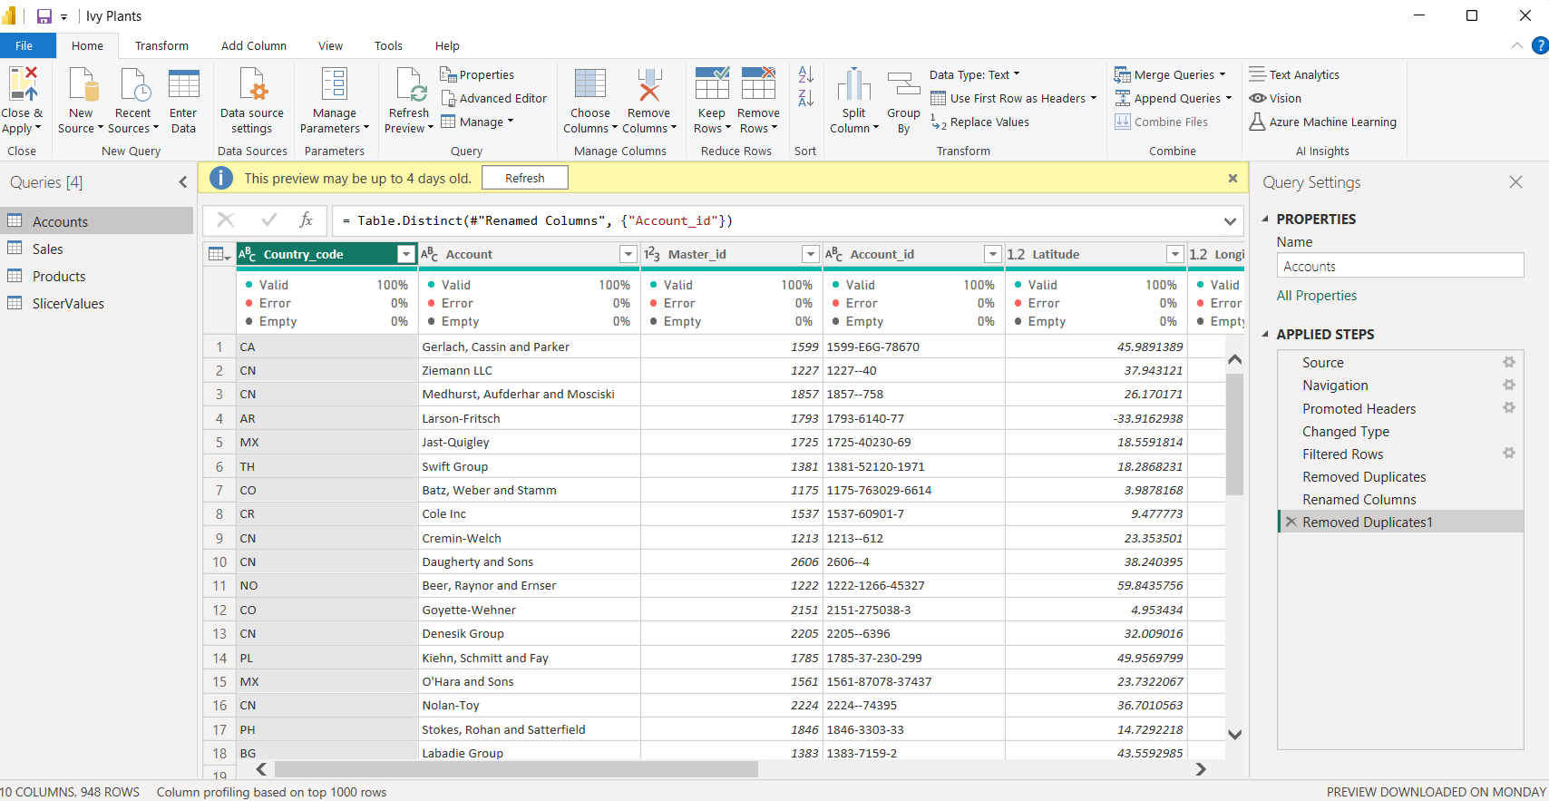
Fig. 1.1 Final table after data cleaning

Satisfied with the final look, I loaded the three tables into Power BI.

The Analysis

- Date Table

I created a DAX Date Table covering the dataset period (2022 - 2024). This was necessary for the Prior-Year-To-Date (P.Y.T.D) values.
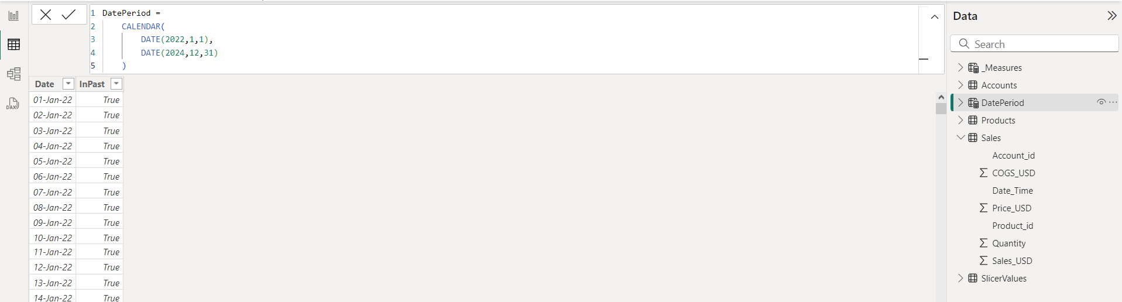
Fig. 2.1. Date Table

P.s. I made significant progress in creating the visuals when I noticed inconsistencies and traced them back to the Date table. I had to create a calculated column, “InPast,” which cross-referenced the dates within the date table with the dates on the Fact Table and returned a ‘True’ or ‘False’ statement for each.

- Base Measures

Then, I created the base measures that would run the dashboard. I created five of them, namely:
- Cost of Goods
- Gross Profit
- Gross Profit Percentage
- Total Quantity
- Total Sales

- P.Y.T.D & Y.T.D Values

Next were the measures for the Year-To-Date(P.Y.T.D) and Prior-Year-To-Date(P.Y.T.D) values. I identified the major metrics the dashboard was going to cycle between as:
- Gross Profit
- Sales
- Quantity
Therefore, the P.Y.T.D and Y.T.D measures were created for each metric.

The dashboard was beginning to come together at this point, and I knew the visuals I wanted. I wanted to show each visual based on the three major metrics and all three on a single dashboard; I needed to create a slicer and switch between them:
- Firstly, I created a table and inputted the three metrics (Gross Profit, Sales, Quantity) as a column called Values
- I created the slicer based on the Values from the table
- Then, I created the switch measures based on the slicer values

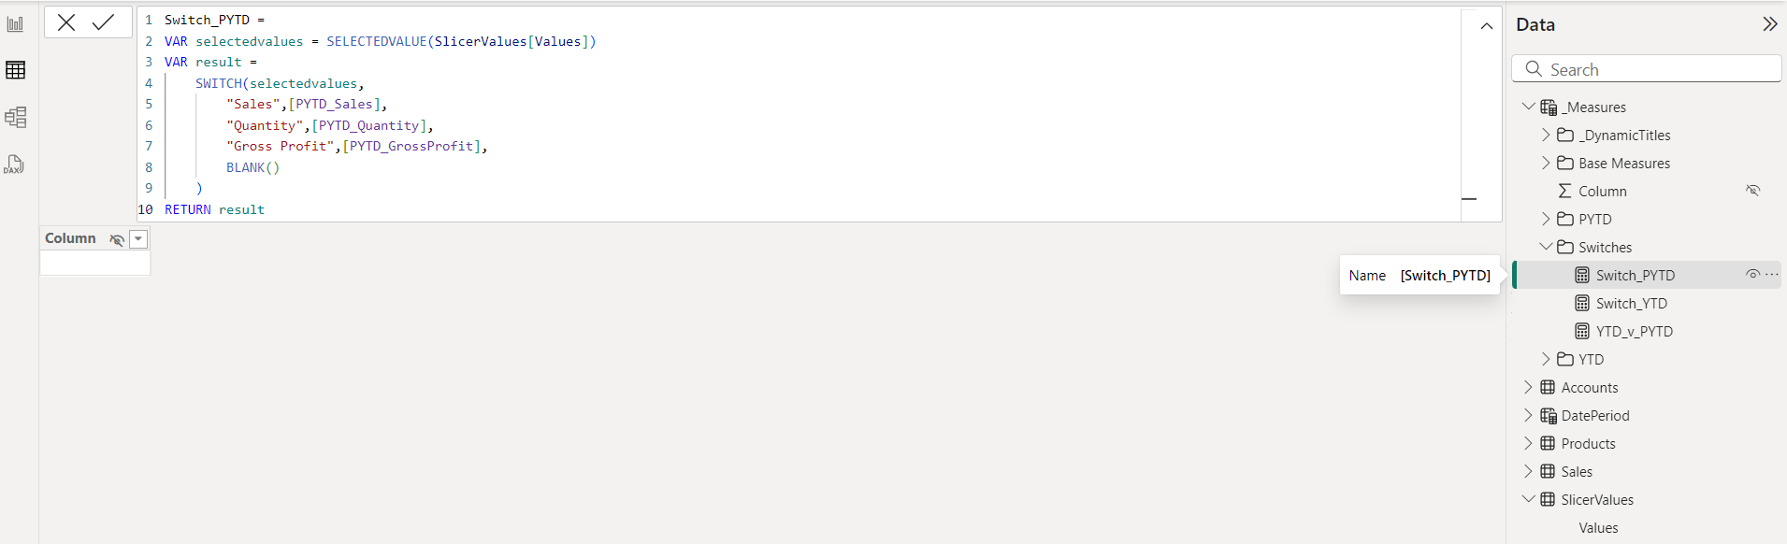
Fig. 2.2. DAX calculation for the PYTD switch measure

I created three switch measures;
- Y.T.D (year-to-date values)
- P.Y.T.D (Prior year-to-date values)
- Y.T.D_v_P.Y.T.D (Y.T.D - P.Y.T.D)

Visualizations

I created each visual to buttress each of the initial research questions posed.

The first visual was a set of dynamic cards to show:
- The total Y.T.D value served as the revenue generated for the fiscal year
- P.Y.T.D: the revenue generated for the previous fiscal year within the same period
- Y.T.D_v_P.Y.T.D; the difference in sales between the current fiscal year and the previous one
- Gross Profit values for the given fiscal year in percentages

Each card showed the information based on the metric selected in the previously created slicer.
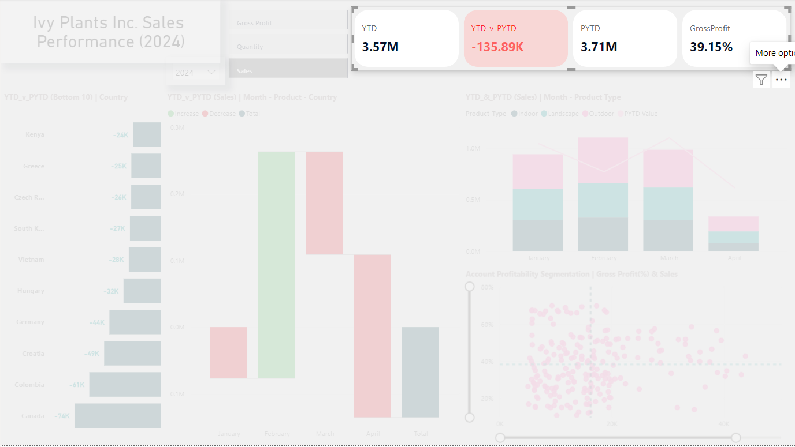
Fig. 2.3. Dynamic cards representing the base measures used in developing the dashboard

I created the second visual to view the Regional Performances at a glance.

I decided to use a clustered bar chart to view the underperforming regions. For each of the three major metrics, the visual showed the bottom 10 countries for the fiscal year in view.
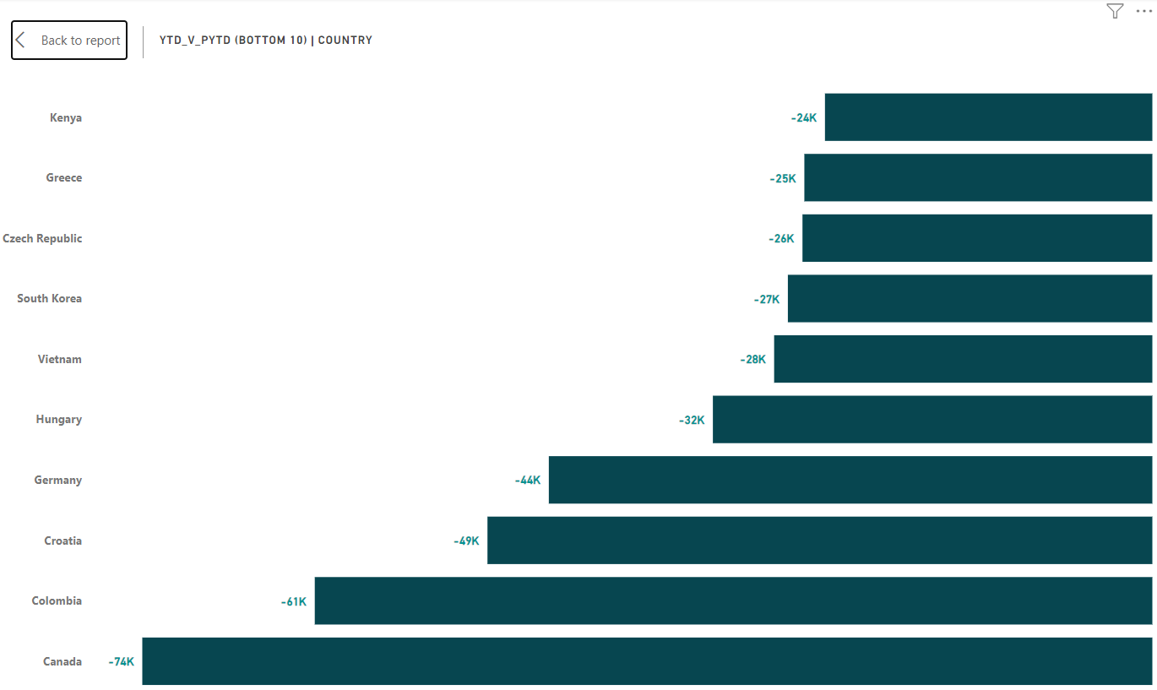
Fig. 2.4. Chart showing the bottom 10 countries based on their Y.T.D sales against their P.Y.T.D sales

I created the third visual to address the difference in sales numbers between the current fiscal year and the previous one.

I went with a waterfall chart displaying the numbers per month and added drill-down options for Country and product type. At a glance, it was clear to see the difference in sales for each month compared to the previous year. Drilling down showed the countries responsible for the numbers and the products’ performances.
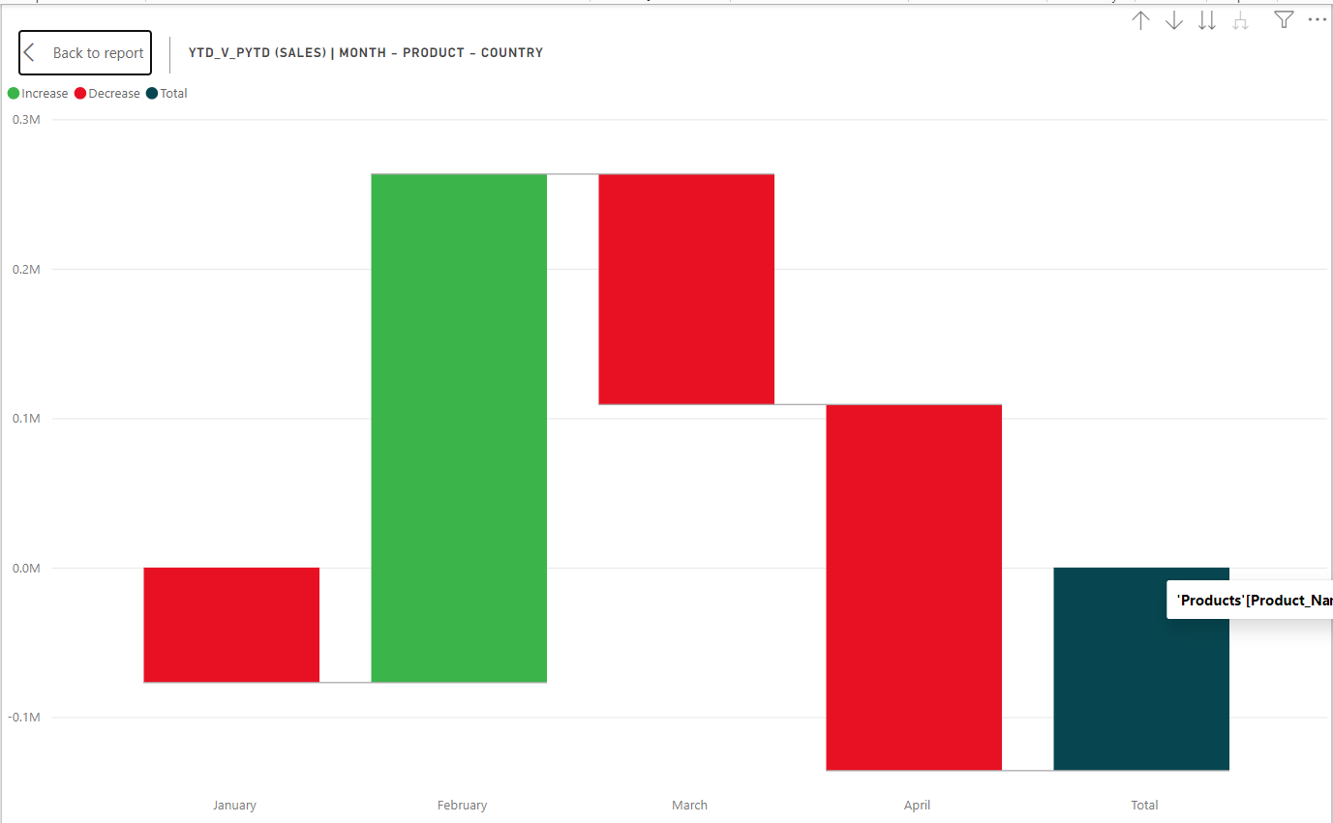
Fig. 2.5. Chart showing Y.T.D sales against P.Y.T.D sales per month for 2024

The fourth visual addressed the business question: what type of plants do customers buy more regularly?

I used a line and stacked column chart to examine the Y.T.D. and P.Y.T.D. values per quarter based on product types for the fiscal year. The columns represented the numbers for each plant type and the total aggregate for the period. The line represented the total P.Y.T.D. value aggregate for the same period. I included a drill-down option for individual months.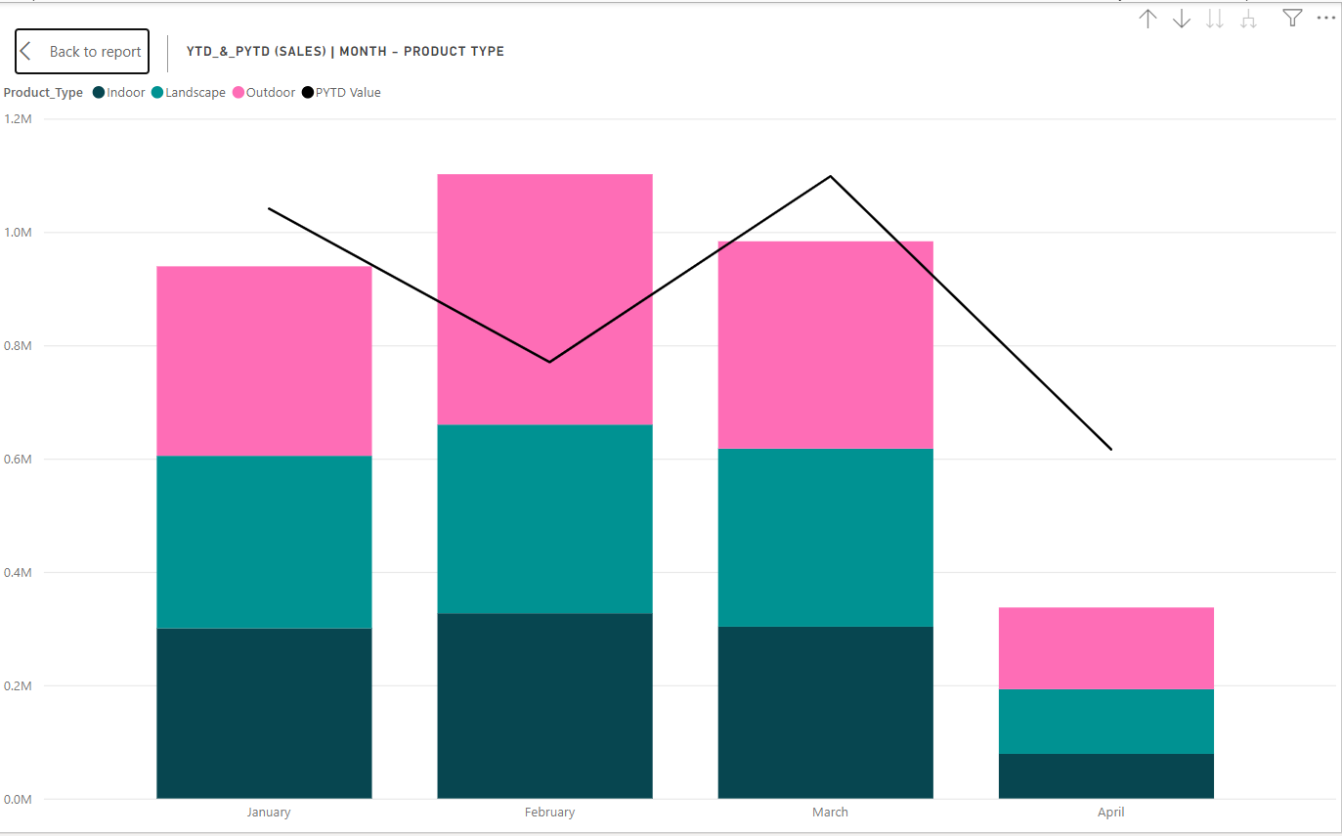
Fig. 2.6. Chart showing Y.T.D & P.Y.T.D sales based on months and product type for 2024

The final visual addressed Account Profitability.

I created a scatterplot that split the accounts into four quadrants based on their Y.T.D value and Gross Profit Percentage.
- The top-left quadrant showed accounts with relatively high gross profit percentages but low numbers (sales and quantity)
- The bottom left quadrant showed accounts with relatively low gross profit percentages and low numbers (sales and quantity)
- The bottom right quadrant showed accounts with relatively high numbers but low gross profit percentages.
- The top right quadrant showed accounts with relatively high numbers and high gross profit percentages.
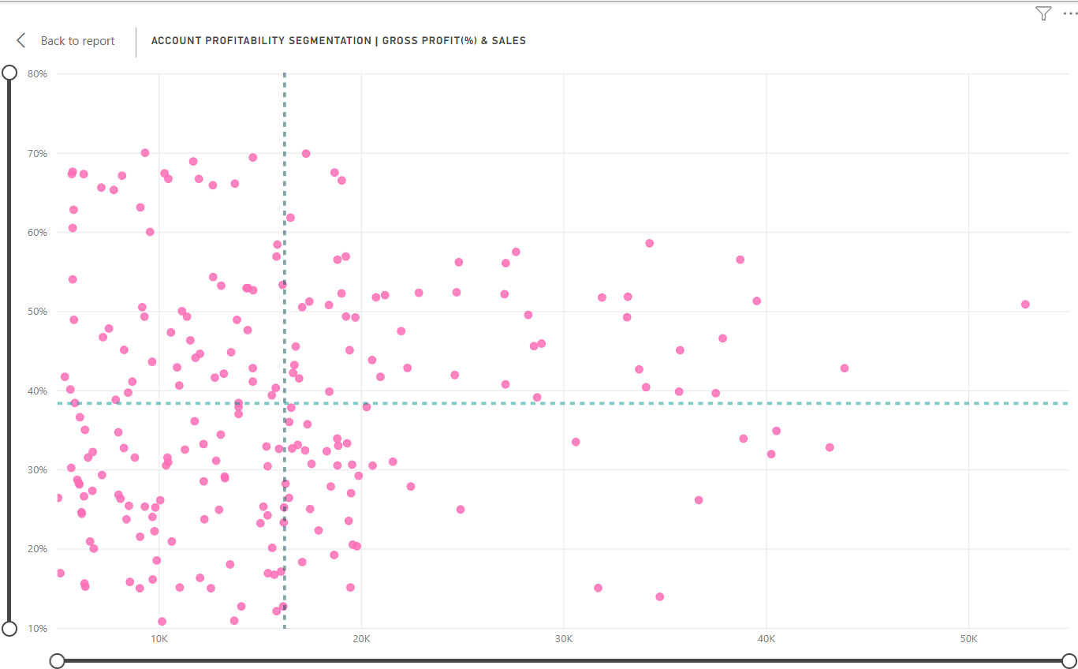
Fig. 2.7. Graph showing account profitability segmentation based on gross profit percentages and sales

Insights and Conclusions

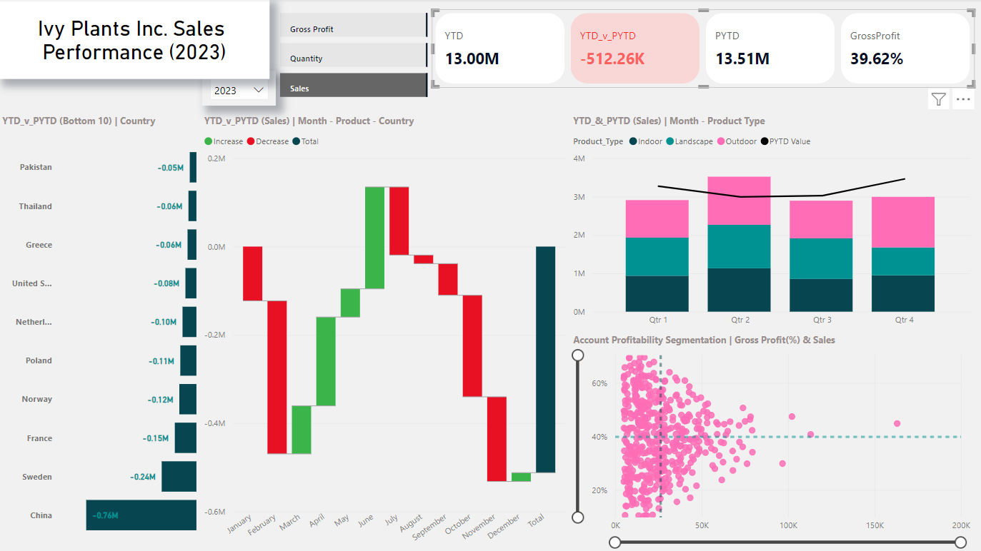
Fig. 3.1. Final Dashboard showing insights for Sales in 2023

